In Microsoft Word, illustrations refer to various visual elements I can add to a document to enhance its appearance and convey information more effectively. These visual elements can include a wide range of items, such as picture, shapes, chart etce.

Adding Picture

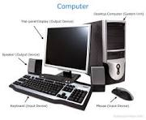

Online picture



Shapes

Smart art

Chart

Screenhot

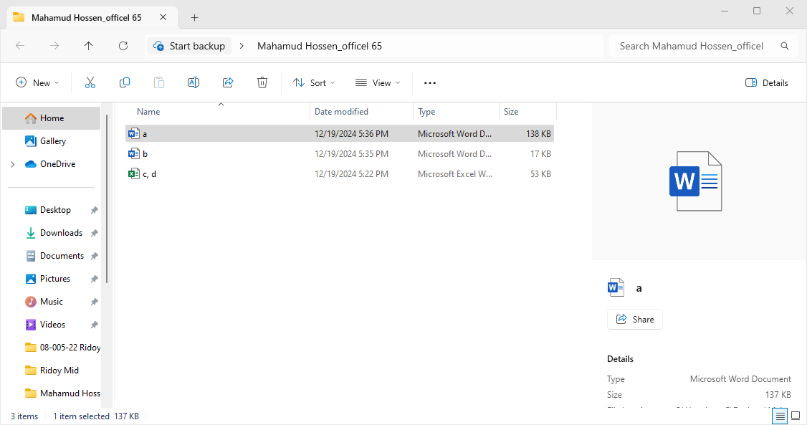



Group shape

|  |  |
| --- | --- |
| Name:Akash  Roll:10  Adress: AIS | Name: Ali  Roll:11  Adress: AIS |
| Name:Abir  Roll:12  Adress: AIS | Name:Antu  Roll:13  Adress: AIS |